# **ipconfig Command**

**ipconfig Command:**

1. ipconfig – Shows Information about PC IP Addresses and Connections.

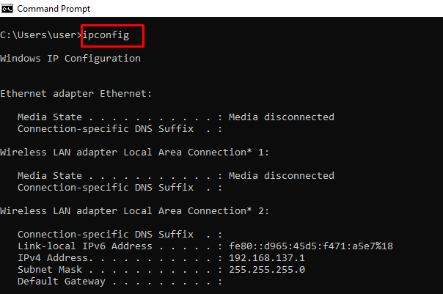

1. This command also has extensions such as ipconfig /release, ipconfig /renew, and ipconfig /flushdns which you can use to troubleshoot issues with internet connections.